**DAX Queries and Screenshots**

**1) Total No. of different flights running**

DistinctFlights:=DISTINCTCOUNT([Flight_Number])

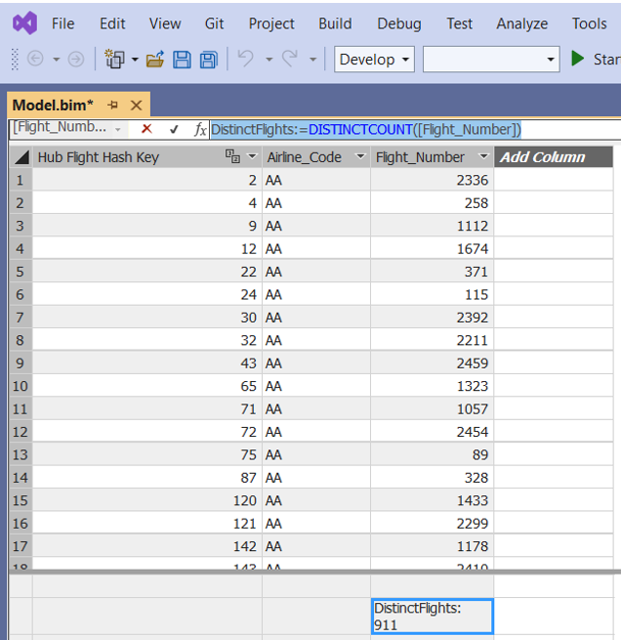

* + - 1. **Create Hierarchy:**

1. **Country**
2. **State**
3. **City**

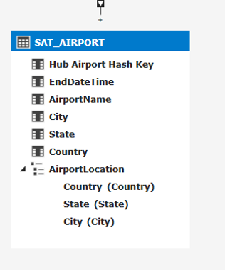

* + - 1. **Flights going to particular country (USA)**

A calculated column ‘Airport_Code’ is created in ‘SAT_AIRPORT’ table

=RELATED('Hub_Airport'[IATA_Code])

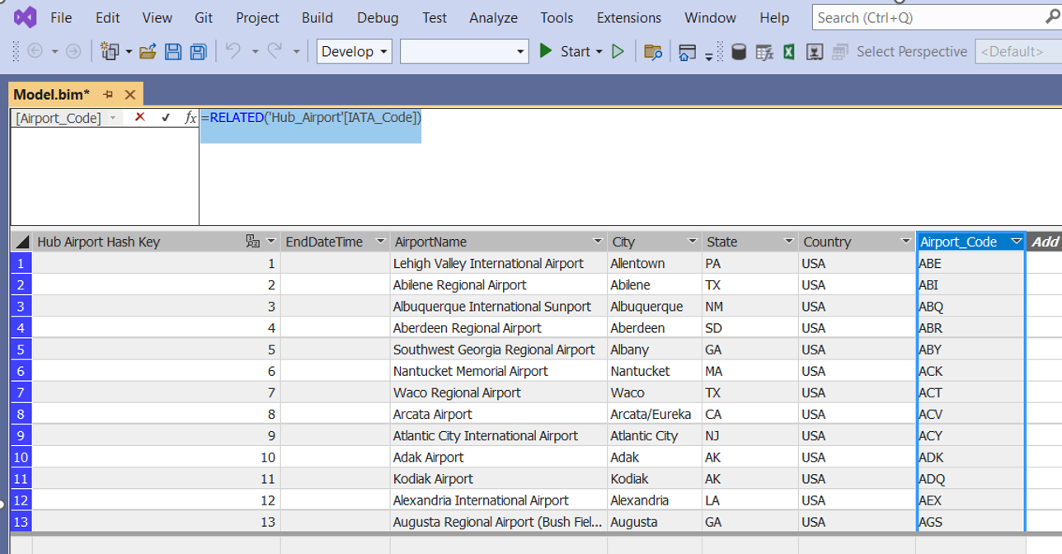

A relationship is created between tables ‘Sat_Airport’ and ‘Sat_Flight1’ through columns ‘Airport_Code’ and ‘Destination_Airport’

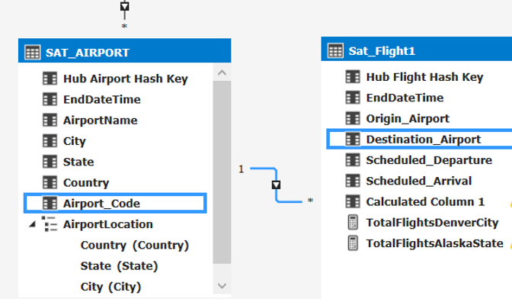

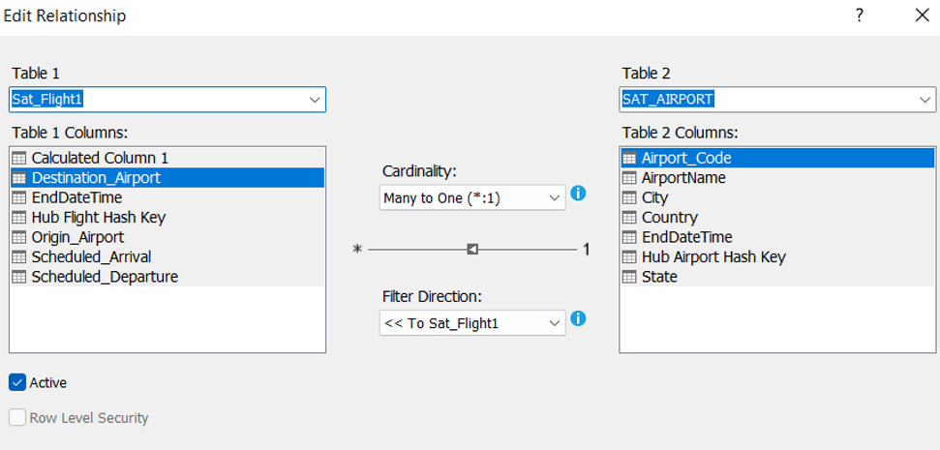

A calculated column ‘Country’ is created in ‘Sat_Flight1’

=RELATED(SAT_AIRPORT[Country])

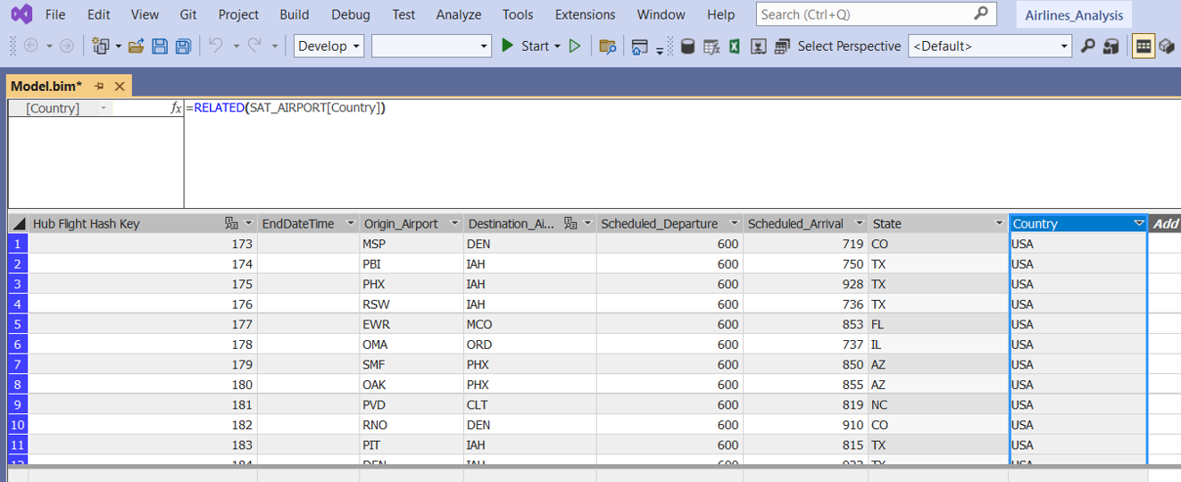

Then total number of flights going to USA is calculated using the query:

TotalFlightsUSACountry:=CALCULATE ( COUNT ( 'Sat_Flight1'[Hub Flight Hash Key] ), FILTER ('Sat_Flight1', [Country]="USA" ))

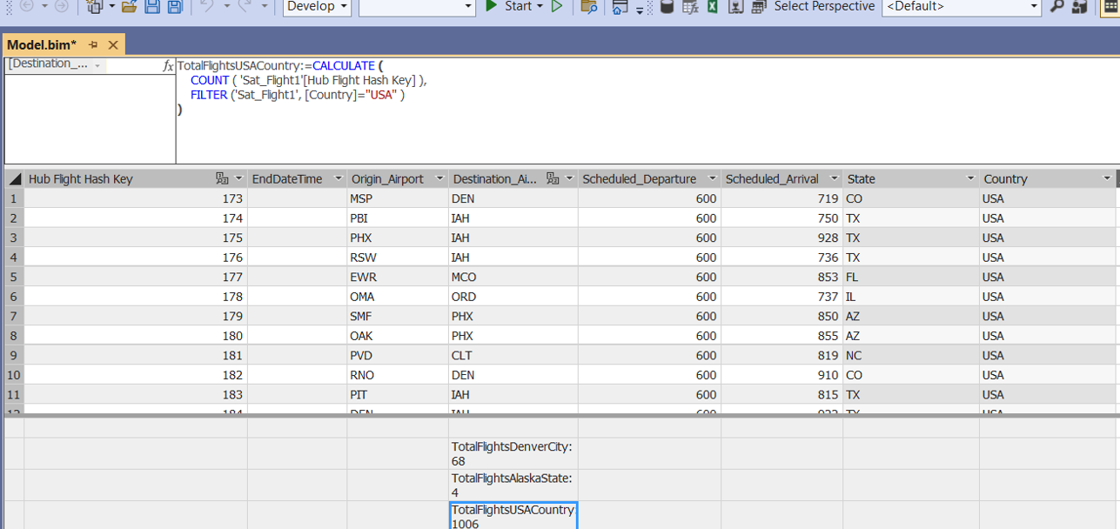

A calculated table ‘FlightsGoingToUSACountry’ is created to display details of flights going to USA

= FILTER('Sat_Flight1', 'Sat_Flight1'[Country]="USA")

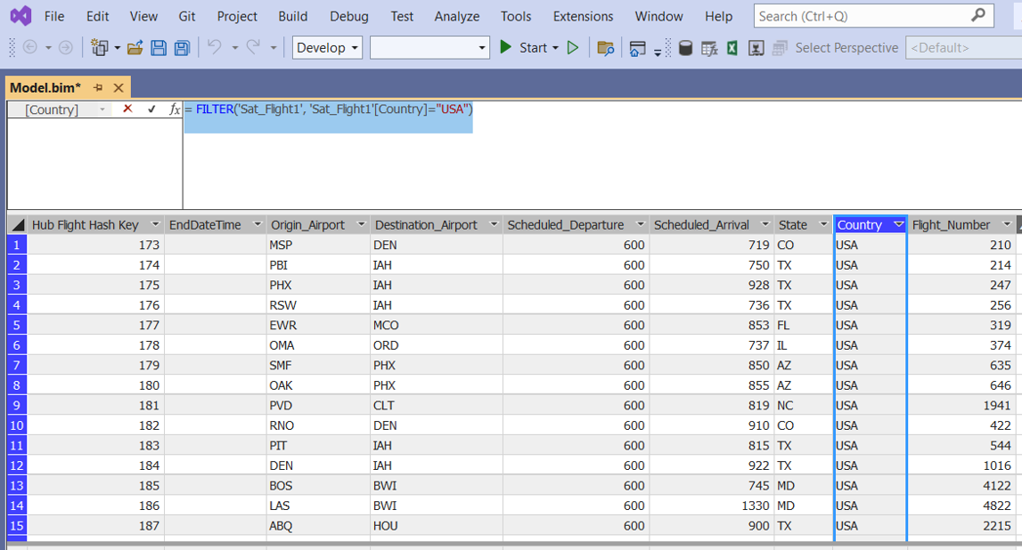

* + - 1. **Flights going to a state (Alaska)**

A calculated column ‘State’ is created in ‘Sat_Flight1’ table

=RELATED('SAT_AIRPORT'[State])

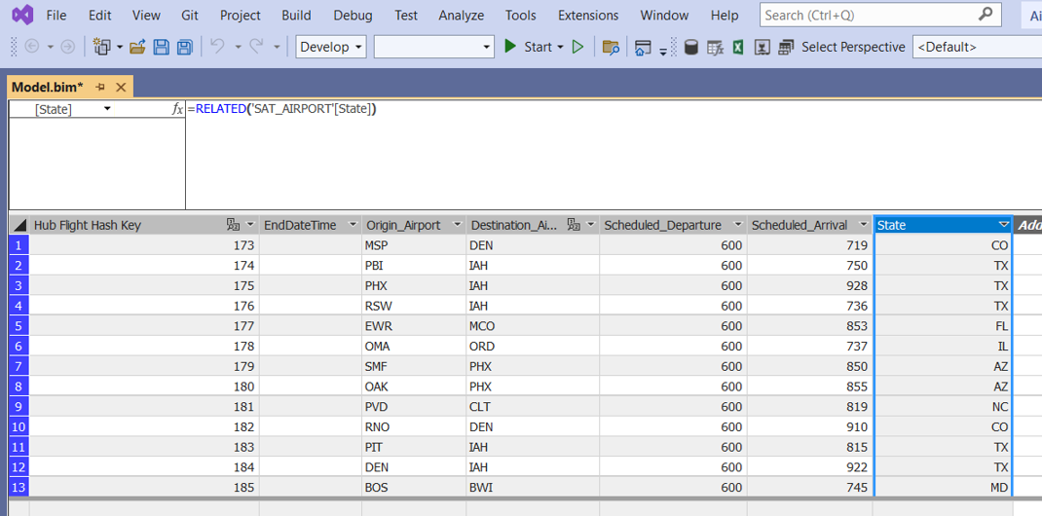

Then total number of flights going to Alaska state is calculated using the query:

TotalFlightsAlaskaState:=CALCULATE ( COUNT ( 'Sat_Flight1'[Hub Flight Hash Key] ), FILTER ('Sat_Flight1', [State]="AK" ))

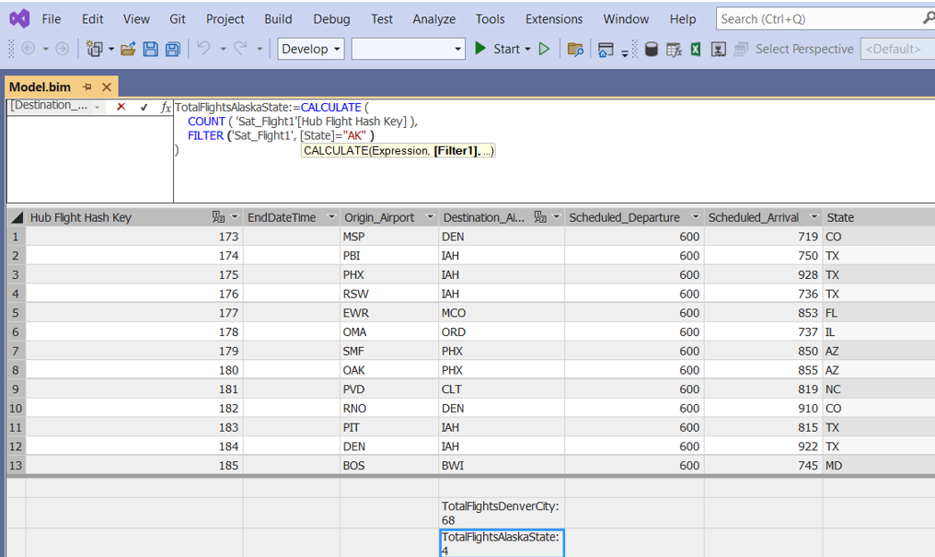

A calculated table ‘FlightsGoingToAlaskaState’ is created to display flight details going to Alaska State

= FILTER('Sat_Flight1', 'Sat_Flight1'[State]="AK")

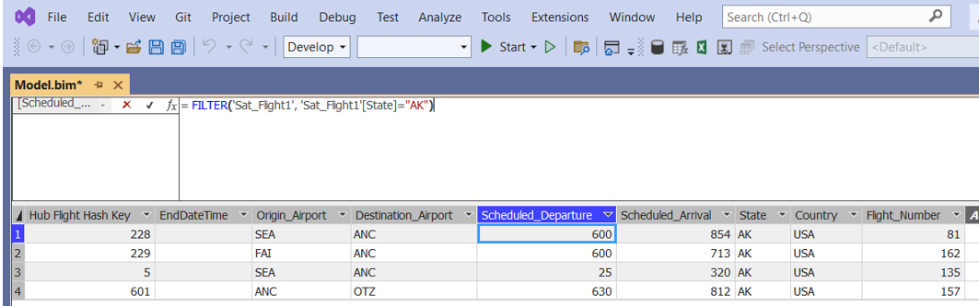

* + - 1. **Flights Going to a city (Denver)**

TotalFlightsDenverCity:=CALCULATE ( COUNT ( 'Sat_Flight1'[Hub Flight Hash Key] ), FILTER ('Sat_Flight1',[Destination_Airport]="DEN" ))

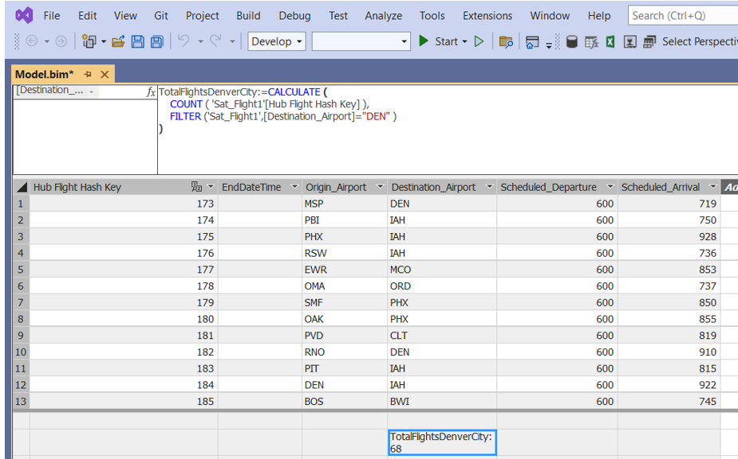

A calculated table ‘FlightsGoingToDenverCity’ is created to find Flights going to Denver city

= FILTER('Sat_Flight1', 'Sat_Flight1'[Destination_Airport]="DEN")

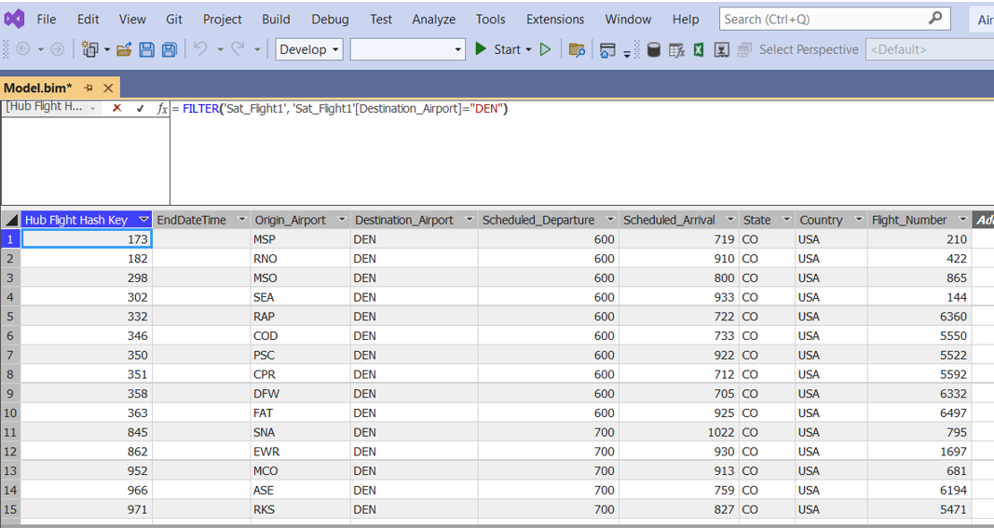

* + - 1. **Perform calculation to Identify Regional/International Airport.**

**To find international airports**

A calculated column ‘InternationalFlag’ is created in ‘SAT_AIRPORT’ table

=IF ( CONTAINSSTRING ('SAT_AIRPORT'[AirportName], "*International*"), 1, 0)

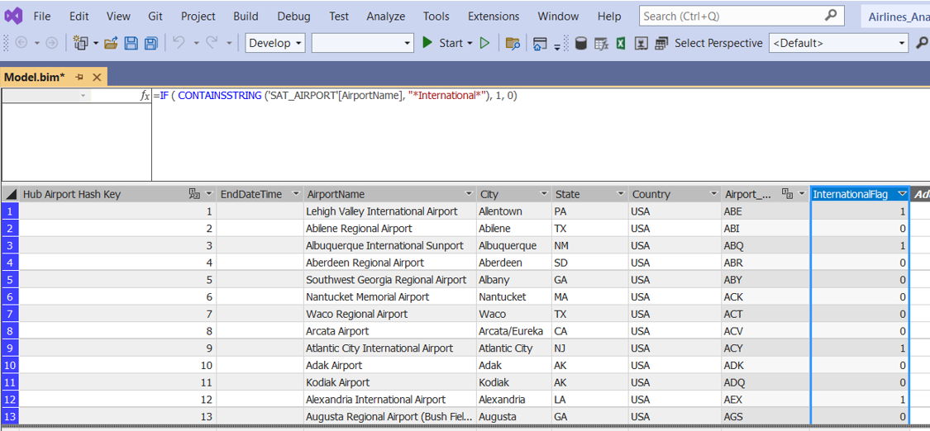

Then total number of international airports is calculated using the query:

TotalInternationalAirports:=CALCULATE (

COUNT ( 'SAT_AIRPORT'[Hub Airport Hash Key] ),

FILTER ('SAT_AIRPORT', [InternationalFlag] = 1 )

)

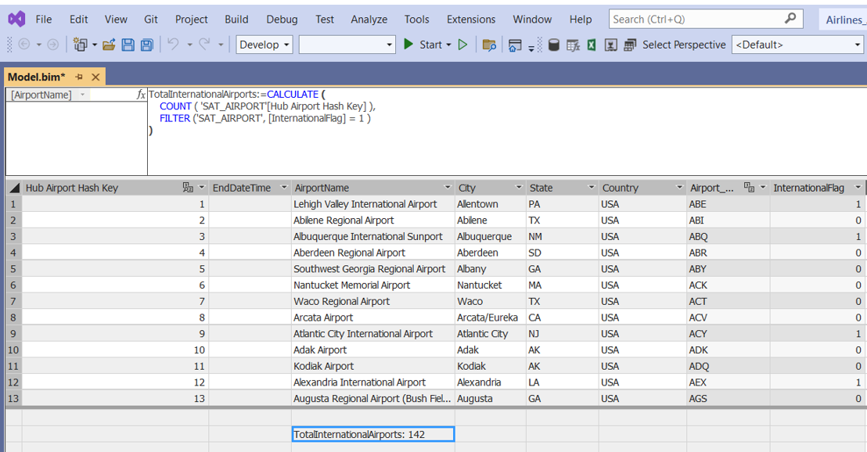

A calculated table ‘InternationalAirports’ is created to show details of international airports

= FILTER('SAT_AIRPORT', 'SAT_AIRPORT'[InternationalFlag]=1)

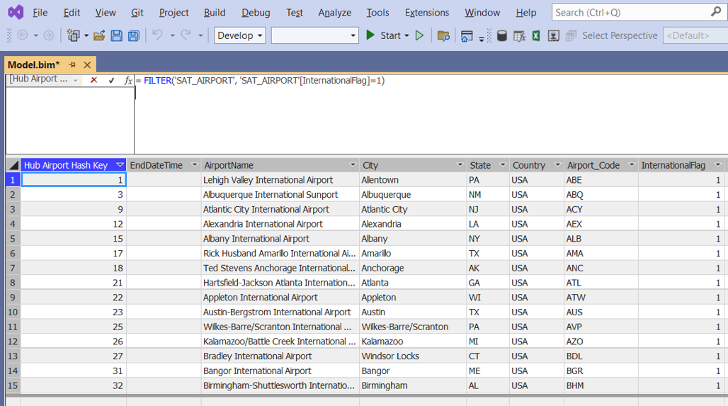

**To find regional airports**

A calculated column ‘RegionalFlag’ is created in ‘SAT_AIRPORT’ table

=IF ( CONTAINSSTRING ('SAT_AIRPORT'[AirportName], "*Regional*"), 1, 0)

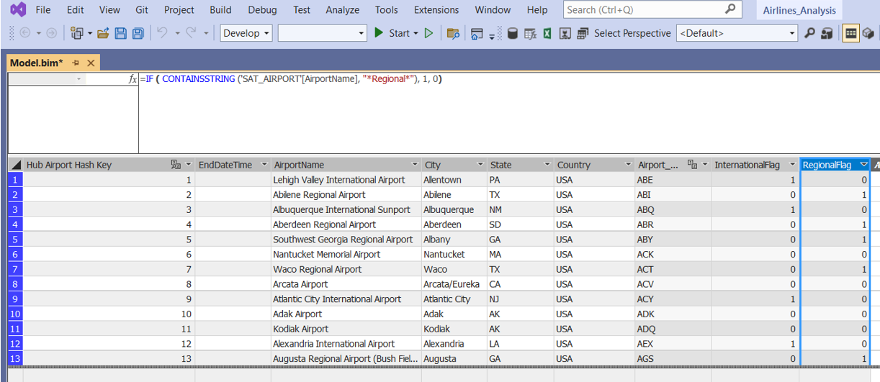

Then total number of regional airports is calculated using the query:

TotalRegionalAirports:=CALCULATE ( COUNT ( 'SAT_AIRPORT'[Hub Airport Hash Key] ), FILTER ('SAT_AIRPORT', [RegionalFlag] = 1 ))

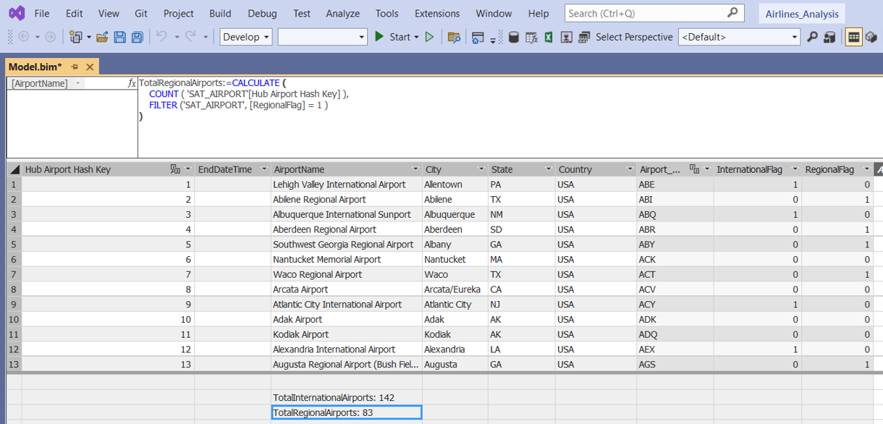

A calculated table ‘RegionalAirports’ is created to show details of regional airports

= FILTER('SAT_AIRPORT', 'SAT_AIRPORT'[RegionalFlag]=1)

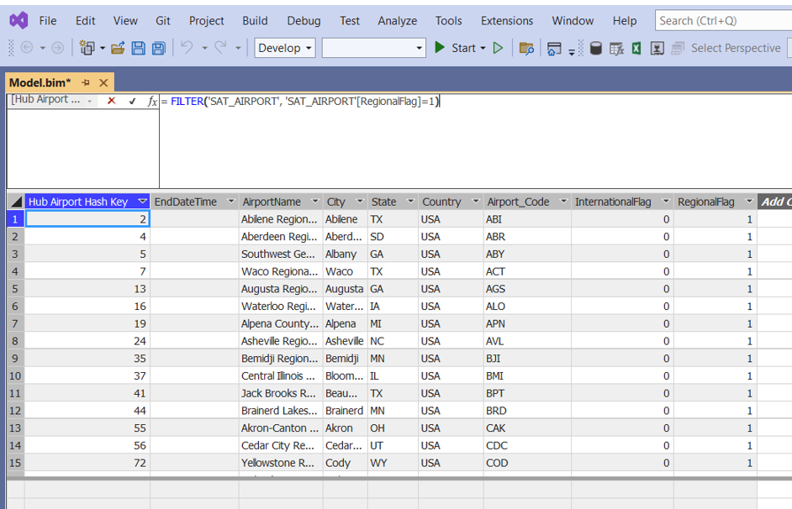

* + - 1. **Flights going to every State.**

A calculated column ‘Flight_Numbers’ is created in ‘Sat_Flight’ table

=RELATED(Hub_Flight1[Flight_Number])

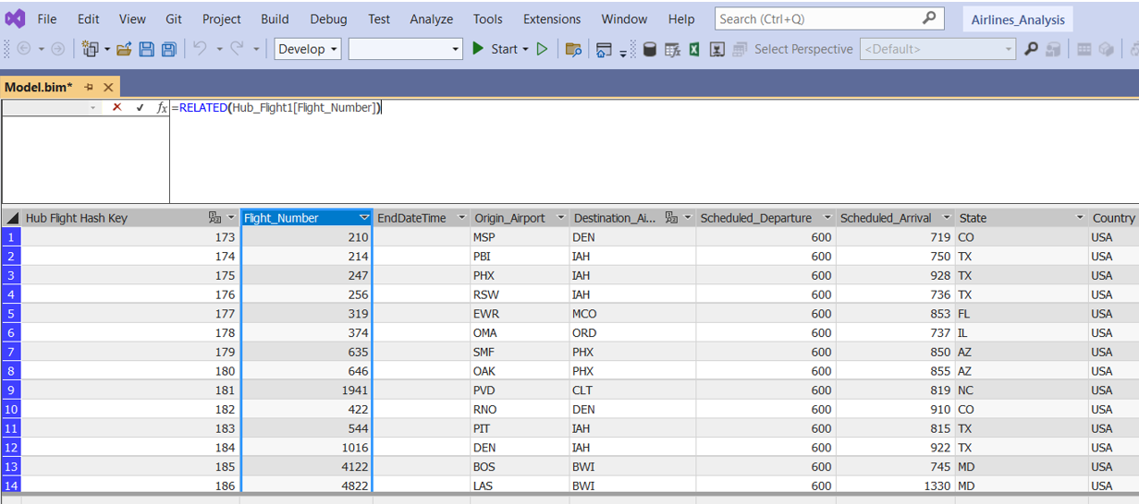

Then a calculated table ‘FlightsGoingToEveryState’ is created to find number of flights going to each state

=GROUPBY('Sat_Flight1', 'Sat_Flight1'[State], "NumberOfRunningFlights", COUNTX(CURRENTGROUP(), COUNT(Sat_Flight1[Flight_Number])))

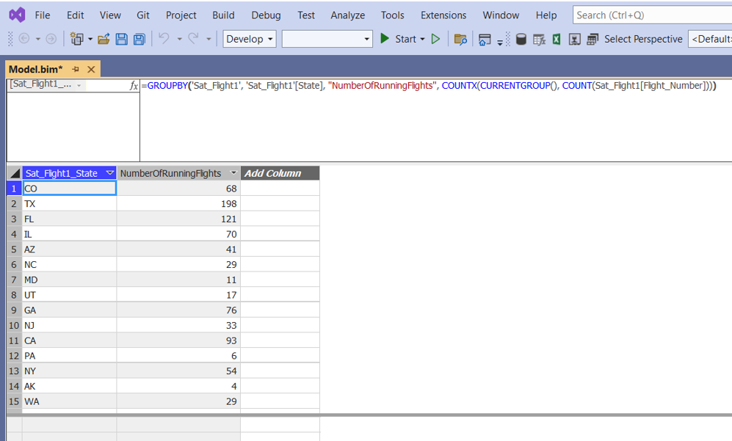

A calculated table ‘FlightsGoingToEveryStateDetails’ is created to show flight numbers of flights going to every state

=GROUPBY('Sat_Flight1', 'Sat_Flight1'[State], 'Sat_Flight1'[Flight_Number]

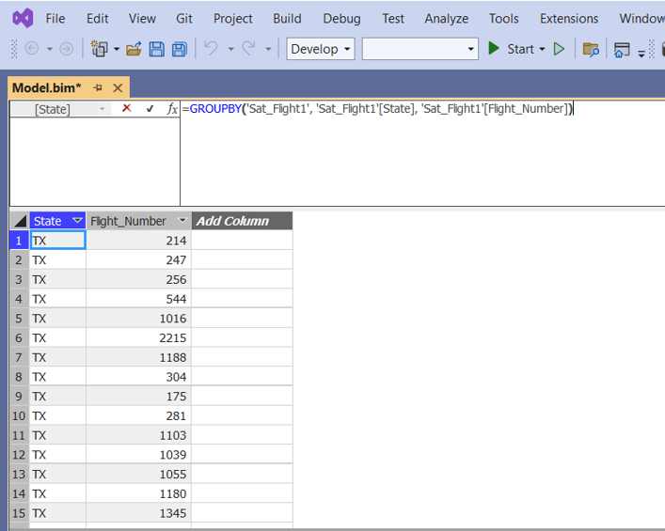

* + - 1. **Find Different Airlines Available**

Total no. of different airlines

DistinctAirlines:=DISTINCTCOUNT([Airline_Code])

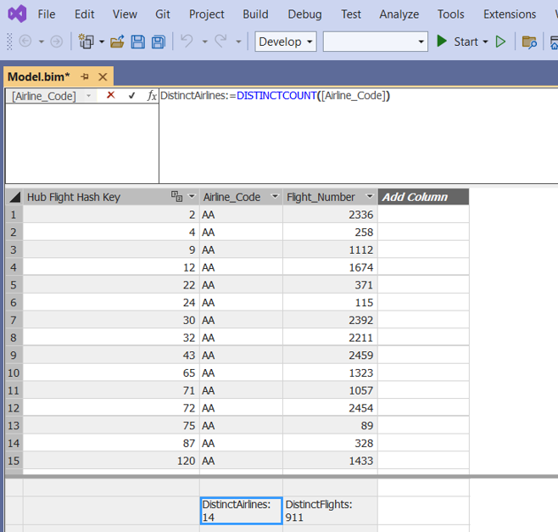

To get names of different airlines create new calculated table ‘NamesOfDifferentAirlines’ is created

=DISTINCT(‘Hub_Flight1’[Airline_Code])

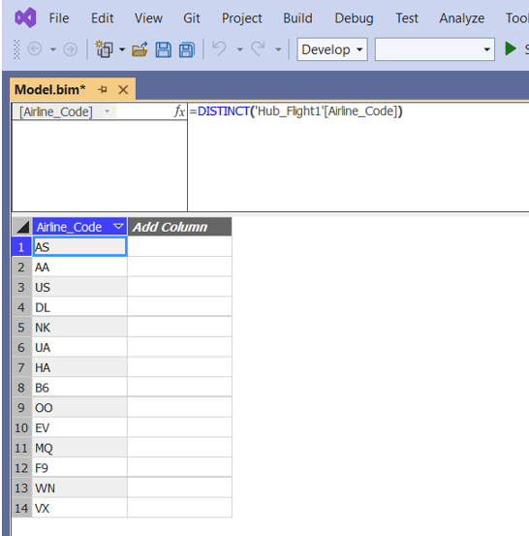

* + - 1. **Which Airline has the maximum running flights**

A calculated table ‘AirlinesWithFlights’ is created

=GROUPBY('Hub_Flight1', 'Hub_Flight1'[Airline_Code], "NumberOfRunningFlights", COUNTX(CURRENTGROUP(), COUNT(Hub_Flight1[Flight_Number])))

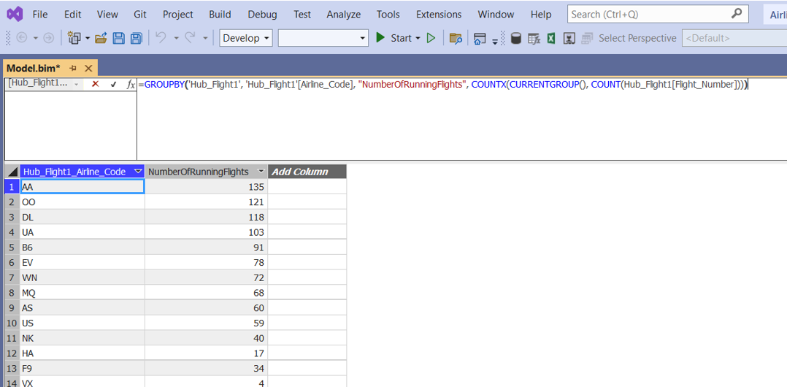

A calculated table ‘AirlineWithMaximumFlights’ is created to find airline with Max number of Running Flights

= FILTER('AirlinesWithFlights', 'AirlinesWithFlights'[NumberOfRunningFlights]=MAX('AirlinesWithFlights'[NumberofRunningFlights]))

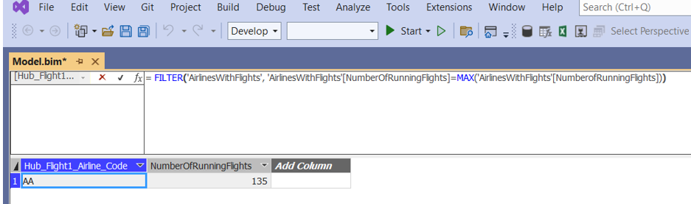

* + - 1. **No of Airports in the state AZ, DE, and NY.**

Number of airports for individual cities:

TotalAirportsAZ:=CALCULATE ( COUNT ( 'SAT_AIRPORT'[Hub Airport Hash Key] ), FILTER ('SAT_AIRPORT', [State] = "AZ" ))

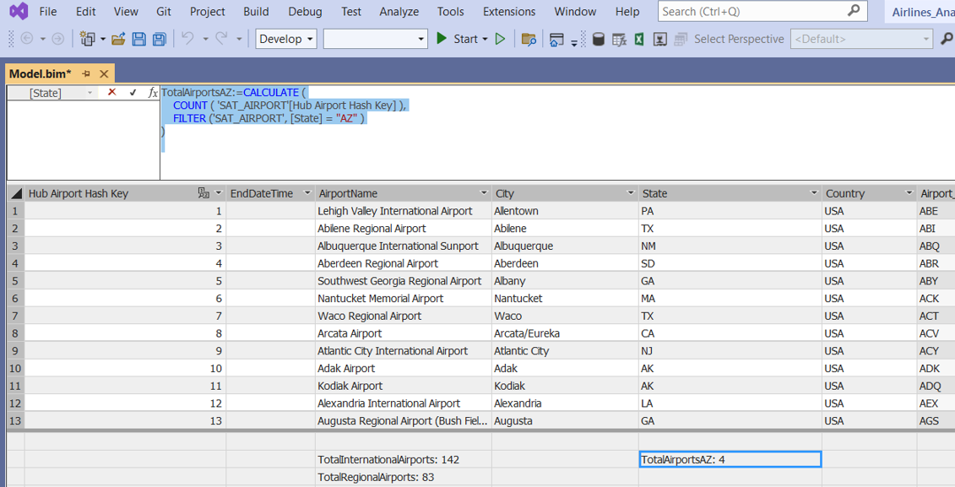

TotalAirportsDE:=CALCULATE ( COUNT ( 'SAT_AIRPORT'[Hub Airport Hash Key] ), FILTER ('SAT_AIRPORT', [State] = "DE" ))

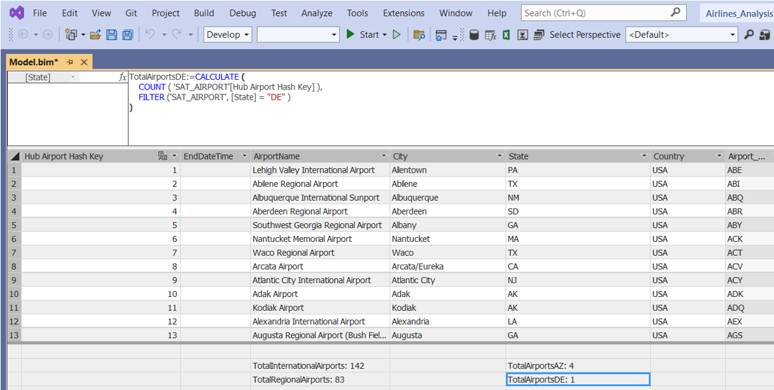

TotalAirportsNY:=CALCULATE ( COUNT ( 'SAT_AIRPORT'[Hub Airport Hash Key] ), FILTER ('SAT_AIRPORT', [State] = "NY" ))

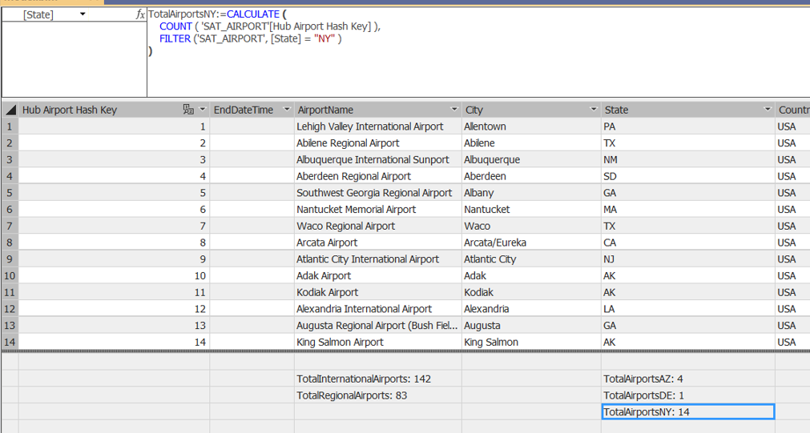

Number of airports for three cities combined:

TotalAirportsAZDENY:=CALCULATE ( COUNT ( 'SAT_AIRPORT'[Hub Airport Hash Key] ), FILTER ('SAT_AIRPORT', [State] = "AZ" || [State] = "DE" || [State] = "NY" ))

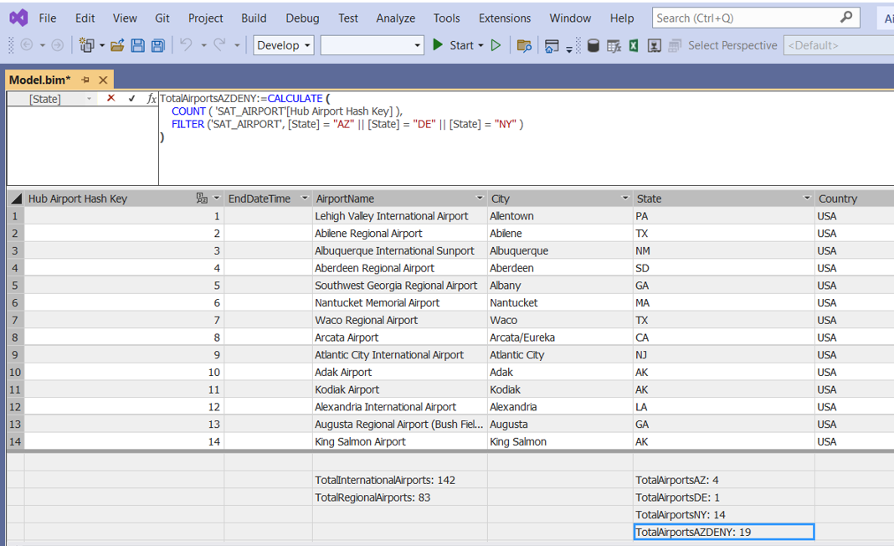

* + - 1. **Create Hierarchy for Airlines and its flight numbers.**

